Name: Vanitha Velagala

Student ID: 700735152

Subject: Machine Learning (CS 5710)

Video link

<https://drive.google.com/drive/folders/1_EeE4IuLZi2grK4-3zQ6GPYu1r_uV8dD?usp=sharing>

Github Link

<https://github.com/Vanitha-19/Machine-learning/blob/main/README.md>

Q1. In the above question first, I have sorted the ages from the given list and found the minimum and maximum ages and then I have calculated the median by taking the average of two middle numbers (i.e., 24, 24 divided by 2) and then calculated the average by adding all the numbers in the list with the given number and lastly, found the range by subtracting the maximum age from the minimum age.

Q2. First create an empty dictionary called dog and then add dog name, color, breed, legs and age to the dictionary. Now create a student dictionary and add first name and last name, gender, age, marital status, skills, country, city, and keys for the dictionary. Now get the values of the skills and check the data type and then modify the skills by adding one or two skills. Now get the dictionary keys and Values as a list.

Q3. In this question first I have created a tuple of brothers and sisters and then added them to the siblings. Now we get the total number of siblings then modify the siblings tuple and add the parents names and assign it to family members.

Q4. In this program we have found the length of IT companies with the given information and then add ‘Twitter ‘to the companies then insert multiple IT companies at one go and delete one of the companies from the set. Now with the given sets A & B join A&B ,finding A intersection B, A subset of B, finding whether A and B are disjoint sets, Join A with B and B with A , Symmetric diff between A&B, delete the sets and lastly convert the ages to a set and compare the length of the list and the set.

Q5. We have to calculate the area of circle and circumference of circle with the radius given 30

Q6. There given a sentence, we have to find the unique words in the sentence

Q7. We have to use the tab escape sequence to the following code

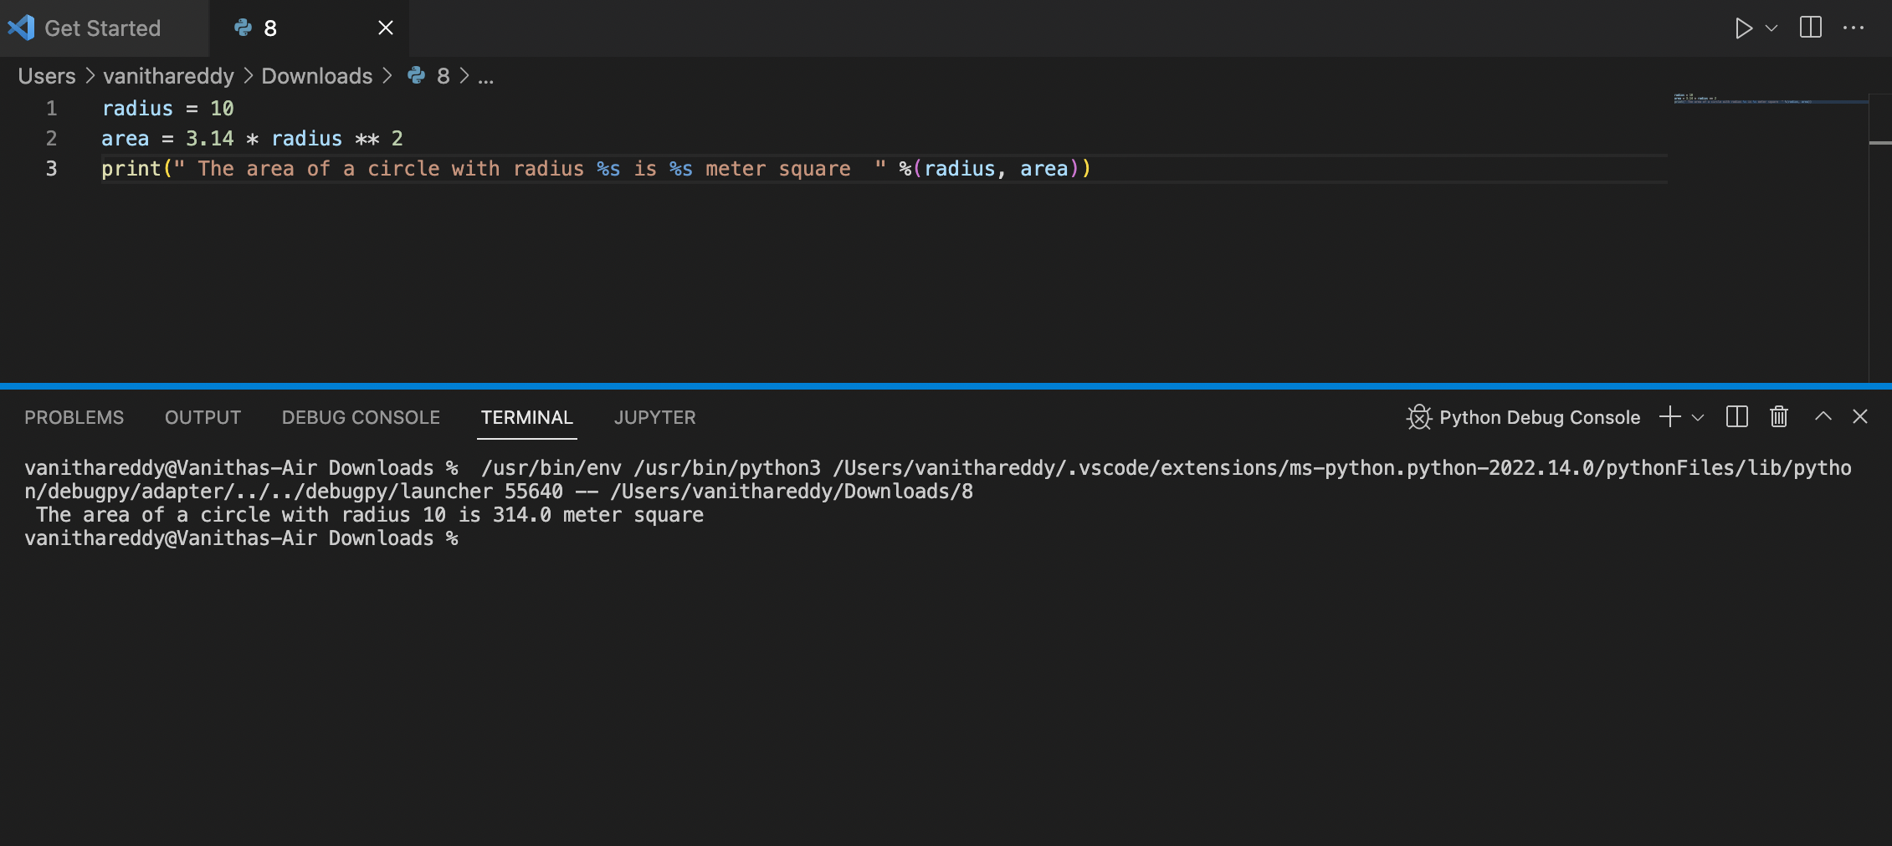

Q8. Here we are using the string formatting method to find the area of circle with given radius.

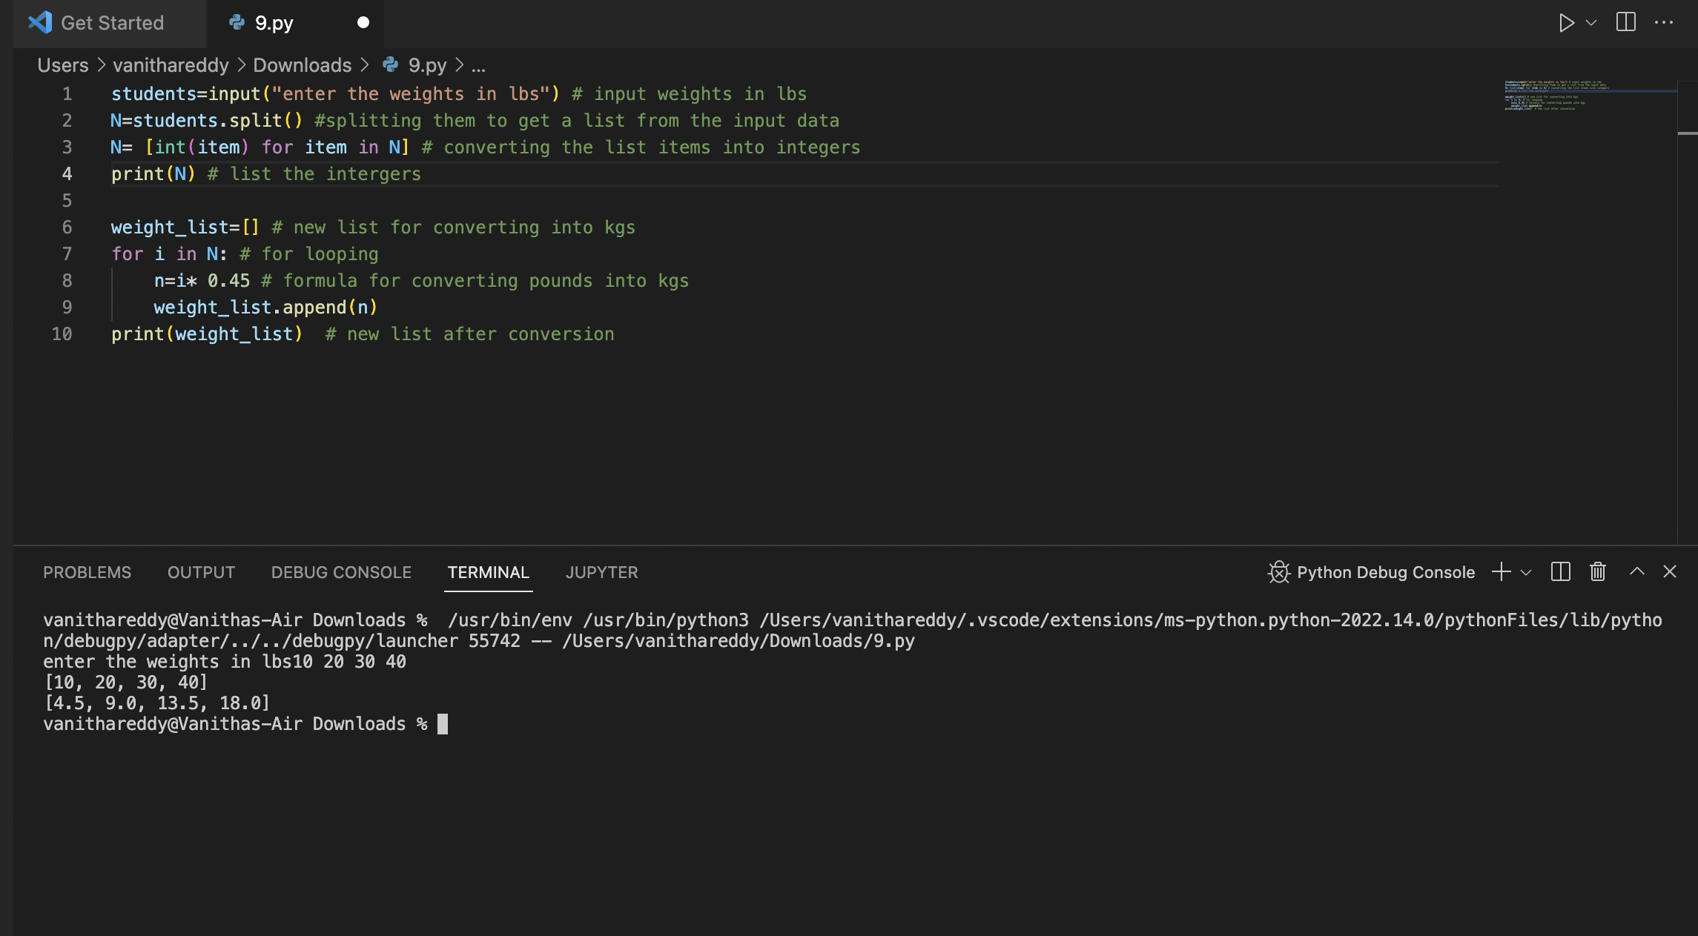

Q9. Here we have converted the weights to kilograms in a separate list using the loop

Q10.

